**5.(Inverted & Rotated Half Pyramid )**

**Exercise**

* **Print the pattern using for loop**



**Approach:**

**So here we did like this**

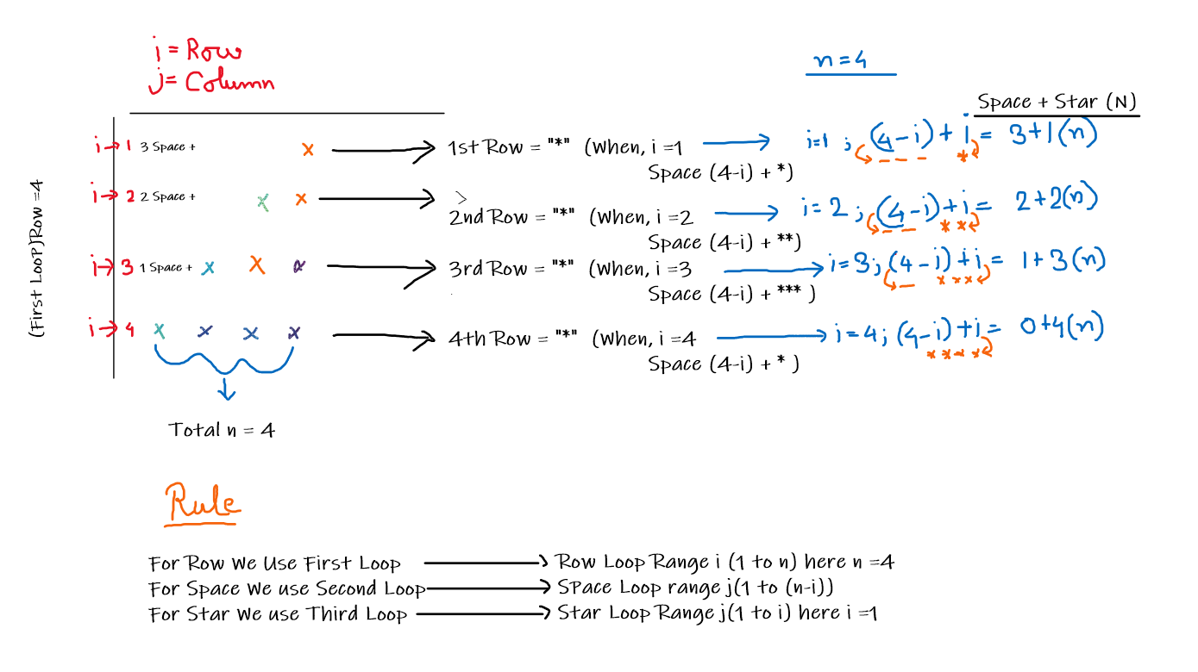

**Solution 👇**

**Java :**

**//Approach -1**

**public class code_xam {**

**public static void main(String[] args) {**

**int n = 4;**

**//For "Row"**

**for (int i = 1; i <= n; i++) {**

**//For "Space"**

**for (int j = 1; j <= n - i; j++) {**

**System.out.print(" ");}**

**//For "Star"**

**for (int j = 1; j <= i; j++) {**

**System.out.print("*");**

**}**

**System.out.println();**

**}**

**}**

**}**

**//Approach -2**

**public class code_xam {**

**public static void main(String[] args) {**

**int n = 4;**

**//For "Row"**

**//similar to Approach -1... 1-4 or 4-1 is same because we have 4 row so if we go backwards, it works fine**

**for (int i = n; i>=1; i--) {**

**//For "Space"**

**/*it's also similar to Approach -1...because when i = 4(n) ;**

**the range of the j will be 1-4 that is total 3 space so for the first row second loop will print 3 space like Approach -1**

**\*/**

**for (int j = 1; j<i ; j++) {**

**System.out.print(" ");}**

**//For "Star"**

**/*it's also similar to Approach -1...because when i = 3 ;**

**and the range of the j will be 0 to (n-i) = (4-3) that is total 1 star(*) so for the first row third loop will print 1 star like Approach -1**

**same as**

**i = 2; range of the j 0 to (4-2) so \*\***

**i = 1; range of the j 0 to (4-1) so \*\*\***

**i = 0; range of the j 0 to (4-0) so ****           */**

**for (int j = 0; j <= n-i; j++) {**

**System.out.print("*");**

**}**

**System.out.println();**

**}**

**}**

**}**

**output:**

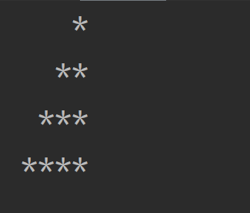

**Python :**

**for i in range(1, 5):**

**for j in range(5, 0, -1):**

**if j > i:**

**print(" ", end=" ")**

**else:**

**print("*", end=" ")**

**print("")**

**output:**

